STILL IMAGE TAKEN FROM THE DOCUMENTARY UTOPIA BY JOHN PILGER

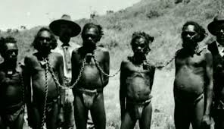

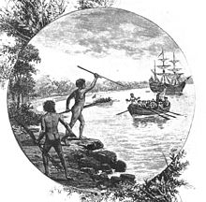
An engraving from "Australia: the first hundred years", by Andrew Garran, 1886 showing natives of the Gweagal tribe opposing the arrival of Lieutenant James Cook in 1770

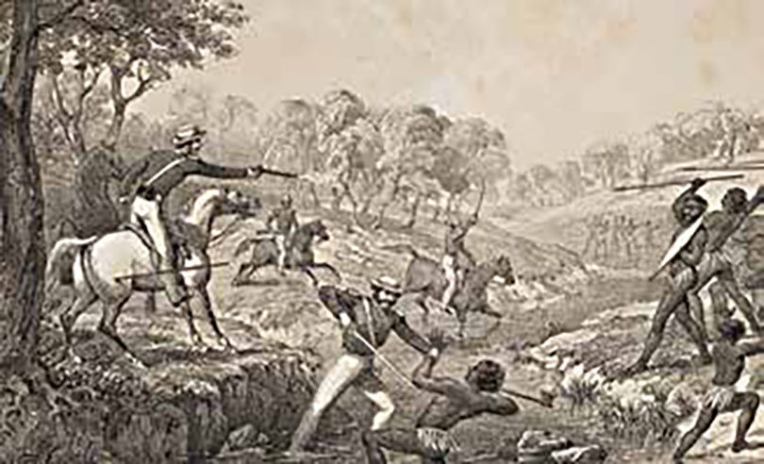
The Slaughterhouse Creek massacre in 1838. Mounted police responded to a conflict at Vinegar Hill on the Liverpool Plains north of central NSW. Sixty to 300 Aboriginal people were reported killed. Illustration: Godfrey Charles Mundy/Australian War Memorial

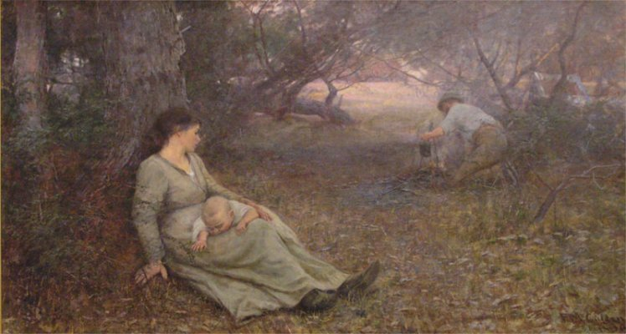

Frederick McCubbin: On the Wallaby Track 1896.

